Excellent Education for All Act Summary

KEY POINTS
The Excellent Education for All Act (House Bill 1) is a transformative plan that ensures more Pennsylvania children have access to an excellent education. It contains four components:
- Increasing the Educational Improvement Tax Credit (EITC) and Opportunity Scholarship Tax Credit (OSTC) programs so students don’t miss out on great opportunities.
- Reforming Pennsylvania’s charter schools while preserving and enhancing choice for families.
- Offering an education opportunity account (EOA) to any school-age child in Pennsylvania. Students cannot enroll in public schools and receive an EOA.
- Protecting learning pods from regulation that would prevent parent cooperation to enhance the education of their children.

why do we need this legislation?
Children have struggled with more than a year of disrupted learning due to the pandemic and mitigation measures. Now, more than ever, parents need a broad range of education options.
- Pennsylvania’s tax credit scholarship programs increase educational opportunities by allowing businesses and community leaders to join in support of Pennsylvania schoolchildren. Unfortunately, the existing program caps don’t meet student need. In 2019 alone, there were nearly 43,000 scholarship denied applications because of the caps. At the same time, there is a waiting list of donors willing to give more than $121 million to eligible students under the EITC and OSTC programs.
- Expanding the tax credit scholarship programs to reflect student need will ensure Pennsylvania students won’t stay on waitlists, desperate for better educational opportunities.
- Charter schools have proven to be the best educational option for hundreds of thousands of Pennsylvania students. These schools are growing as cyber charter enrollment surged 59% last school year. Broad consensus exists that the state’s aging charter school law needs reforms—ones that will treat charter students more equitably and ensure the highest ethics among charter operators.
- Children deserve an education that best fits their individual needs. But some parents face challenges when it comes to providing their children with a great education. The EOAs in the Excellent Education for All Act would equip parents with resources to get their children the education that works for them.
- While learning pods are not new, the COVID-19 pandemic has brought much more interest and visibility to the concept. Unfortunately, there are examples of state agencies and/or districts moving to regulate this activity. Parents should be free to privately cooperate to enhance the educational experiences of their children without permission of the state.
How Does HB 1 impact EITC and OSTC?
This legislation provides for the following increases beginning in FY 2021–2022:
- Increase the EITC program cap from $225 million to $250 million:
- Credits for K–12 scholarships go from $175 million to $185 million.
- Credits for Pre-K scholarships go from $12.5 million to $15 million.
- Credits for Educational Improvement Organizations go from $37.5 million to $50 million.
- Increase the OSTC program from $55 million to $150 million.
- Each program would thereafter increase by 25% annually if businesses claim 90% of the available tax credits in the previous year.
These amounts are a small fraction of the $32.7 billion spent on public schools last year.
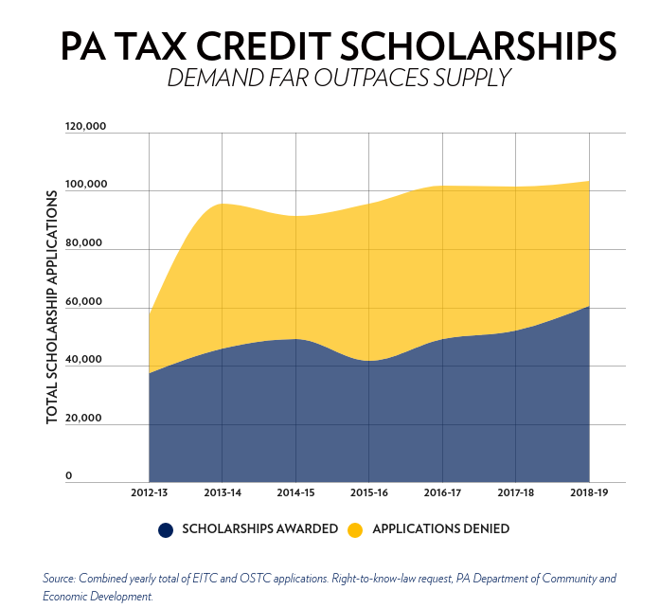

What is the financial impact of the EITC/OSTC changes?
The average tax credit scholarship is just $2,100, which is nearly 90% less than the $19,100 spent per student in Pennsylvania public schools. An 2020 analysis by Dr. Martin Lueken of EdChoice concluded that a $100 million EITC increase would save state and local taxpayers a combined $265 million. The projected savings from HB1 are even greater.
From the district’s financial perspective, increasing tax credit scholarships is a massive boon since districts retain all local funding for students who are no longer attending their schools.

How does hb1 impact charter schools?
Charter school reforms include stronger and clearer ethics requirements for charter school leaders and charter appeal board accountability. HB 1 reforms create alternative authorizers for charter schools, access for charter school students to school buildings and testing sites, and allow charter school students the opportunity to participate in dual enrollment programs at institutions of higher education, just like their peers in district schools.

What is the financial impact of the charter school changes?
School districts exist to facilitate the education of children—funded by taxpayers—at public schools. When children remain at the district school, the district pays the cost of educating them within the district. When children choose charter schools, the district pays the cost of educating them at charter schools.
On average, Pennsylvania charter schools receive less funding per student, as school districts keep around 25% of funding for students who attend charter schools—paying around $15,000 per child at charter schools, compared to $19,500 per child at district schools. Charter school funding is based on each district's per-pupil costs after subtracting certain expenditures like transportation, facilities, and debt services.
As of 2020, if charter schools received the same amount of funding per student as district schools, they would receive nearly $2.9 billion for the nearly 147,000 students enrolled. Instead, they received less than $2.5 billion. In other words, charter schools are saving school districts and taxpayers $400 million per year. Charter school expansion would likely result in additional savings as charters tend to operate on less funding than district schools.
It’s worth noting that charter school funding increases as enrollment increases. If no students enroll in a charter school, the school will receive no funding. At district schools, there is no such link, as illustrated in the chart below.
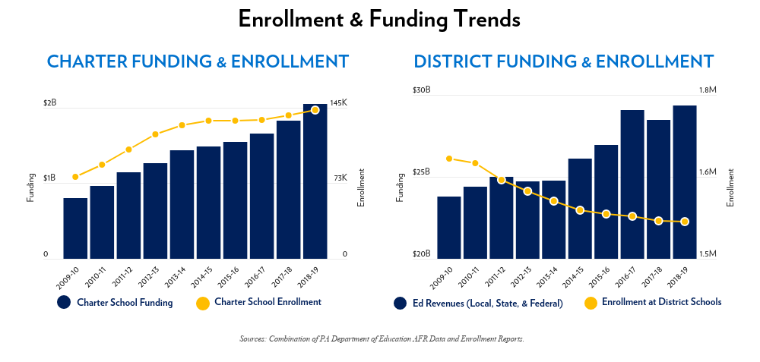
How do EOAs work under hb 1?
- Each participating child would receive an amount equal to the average state funding per student minus transportation funding. In 2019-2020 (most recent data available), this equaled around 6,700 per student.
- For eligible students with special needs, this base amount would increase using the state special education multiplier:
- For an eligible student in Category 1 (special education students costing district schools between $1 and $24,999), multiply the base amount by 1.51.
- For an eligible student in Category 2 (special education students costing district schools between $25,000 and $49,999), multiply the base amount by 3.77.
- For an eligible student in Category 3A and 3B (special education students costing district schools $50,000 or more), multiply the base amount by 7.46.
- Education opportunity account funds would be for “qualified education expenses,” which include:
- Tuition, fees, and uniforms.
- Fees for tutoring or other teaching services.
- Fees for a nationally norm-referenced test, AP, or similar examination or standardized examination required for admission to an institution of higher education, as well as career and technical education examination fees.
- Curriculum, textbooks, or other instructional materials.
- Hardware, software, and internet connectivity associated with instruction or any of the qualifying education expenses.
- If the eligible student is a student with special needs, fees for special instruction or special services provided to the eligible student, including, but not limited to, occupational, physical, speech, and behavioral therapies.
- Costs associated with evaluation and identification of special needs.
- Other valid educational expenses approved by the Pa. Department of Education.
- If funds remain in the account two years after a student has graduated high school, these funds would then return to the General Fund.
What is the financial impact of EOAs?
Because EOAs would receive funds using the average per pupil education subsidy, there will not be a significant fiscal impact on the state budget.
- Individual school districts will no longer receive the average per pupil state education subsidy for the children who no longer attend district schools. However, they will retain all local and federal funds. Districts will not need to send payments to parents for the accounts.

How do learning pods work under hb 1?
- The legislation defines “Learning Pods” and “Operation of a Learning Pod” to cover all voluntary associations of parents to provide educational enhancement for their children and makes clear that the payment by parents for any services to the pod does not exclude them from the protections of the act.
- The act creates a series of specific exemptions from the regulatory reach of state, local, and district regulatory agencies, including exemptions from educational code provisions such as staff ratios and building and fire-code regulations applicable to institutions, and any other new regulation that would not exist but for the operation of the learning pod.
- The act creates a series of affirmative protections for learning pods to ensure that parents and children are not subject to undue surveillance, reporting, regulatory demands, or harassment.

Marc LeBlond, “Opportunity Finds a Way,” Commonwealth Foundation, https://www.commonwealthfoundation.org/policyblog/detail/opportunity-finds-a-way. Business Donations Waitlisted via Right to Know requests from the Department of Community and Economic Development, https://infogram.com/eitcostc-business-donations-1h7j4dvw07gev4n?live.
Avi Wolfman-Arent, “New Pa. Data Shows How the Pandemic Gave a Big Boost to Cyber Charter Schools,” WHYY, (December 2020), https://whyy.org/articles/new-pa-data-shows-how-the-pandemic-gave-a-big-boost-to-cyber-charter-schools/.
Dr. Martin Lueken, “Fiscal Impact Statement, Pennsylvania 2020 Budget Session,” EdChoice, (May 2020), https://www.commonwealthfoundation.org/docLib/20200520_PAHB800FiscalNote_FY2021.pdf?t=5/20/2020%205:10:27%20PM.
Nathan Benefield, “5 Takeaways from Governor Wolf’s 2020 Budget Address,” Commonwealth Foundation, https://www.commonwealthfoundation.org/policyblog/detail/5-takeaways-from-governor-wolfs-2020-budget-address.
“AFR Data Detailed,” Pennsylvania Department of Education, (May 2021), https://www.education.pa.gov/Teachers%20-%20Administrators/School%20Finances/Finances/AFR%20Data%20Summary/Pages/AFR-Data-Detailed-.aspx#.VZwC6mXD-Uk
“Special Education Funding,” Pennsylvania Association of School Business Officials, (Accessed September 2021), https://www.pasbo.org/specialeducation.

